ARGENTINA

GOLF

BUENOS AIRES + PATAGONIA

SAMPLE ITINERARY



We have several possible Argentina tour itineraries to offer.

From the simple one visiting Buenos Aires and its surrounding

areas, to the more complex ones, including traveling to Patagonia, the Waterfalls and/or the Wine are in Mendoza.

It all comes down to your budget, tour length and tour goals. All

of our itineraries are 100% arranged by us without intermediaries,

offering the best costs. Fully customisable to your needs.

TOUR ITINERARY

---

DAY 0 |

---
Departure from your local International Airport
Flight to Buenos Aires International Airport
Welcome lunch
Afternoon guided city tour
Group dinner

Night in Buenos Aires

---

DAY 1 |

---
Breakfast at your accommodation
Bus transfer to the golf course
Bus transfer back to hotel
Free evening to visit the city
Night in Buenos Aires


---

DAY 2 |

---
Breakfast at your accommodation
We keep exploring Buenos Aires
Free evening
Optional: training session
Night in Buenos Aires


---

DAY 3 |

---

Breakfast at your accommodation
Bus transfer to the golf course
City tour in the afternoon
Dinner and Tango in Buenos Aires.
Night in Buenos Aires
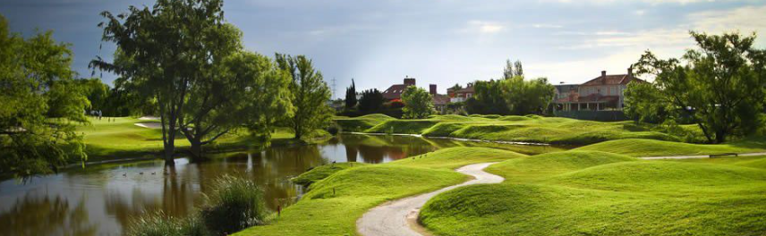

---

DAY 4 |

---
Breakfast at your accommodation
Bus transfer to airport heading to Bariloche
Arrive at Bariloche and bus transfer to your hotel
Cerro Otto or town exploration
Chocolate tasting in Bariloche Centro
Patagonian lamb or local specialties for dinner
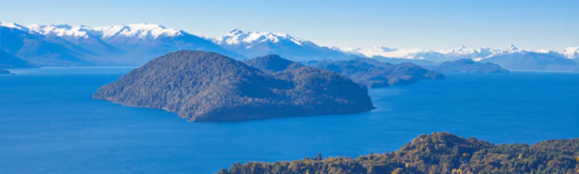
Night in Bariloche

---

DAY 5 |

---
Breakfast at your accommodation
Bus transfer to the golf course
Cerro campanario (optional): Chairlift viewpoint, a short stop right along the same route
Brewpub on Lago Moreno
Night in Bariloche

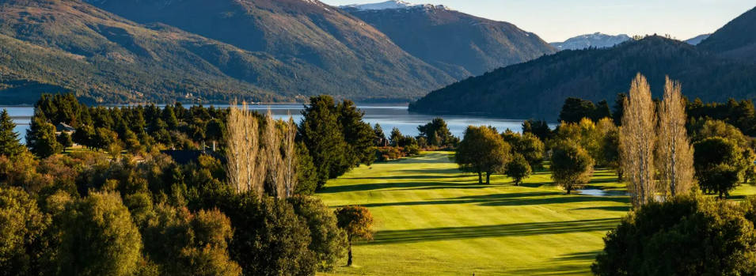

---

DAY 6 |

---
Breakfast at your accommodation
Scenic transfer through the Seven Lakes route, stopping in Villa La Angostura
Boat or catamaran to Quetrihué peninsula, or bike/trek in for the more active
Walk around the town in the afternoon and continue the Seven Lakes route to San Martin de los Andes.
Night in San Martin de los Andres

---

DAY 7 |

---
Breakfast at your accommodation
Bus transfer to the golf course
Optional: boat trip on Lago Lacar in the afternoon (depends on weather) or hiking
Night in San Martin de los Andres
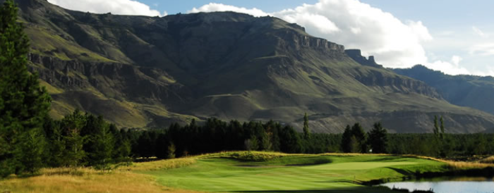

---

DAY 8 |

---

Breakfast at your accommodation
Free time: Lakefront town, boutique shopping, chocolate shops
Bus transfer to airport heading to Buenos Aires
Arrive at Buenos Aires and bus transfer to your hotel

---

DAY 9 |

---
Breakfast at your accommodation
Free day
Flight back home

