BARCELONA

GOLF BREAK

BARCELONA + GIRONA

SAMPLE ITINERARY



We have several possible Spain tour itineraries to offer. From the simple one visiting Girona and/or Barcelona and their surrounding areas, to the more complex ones, combining Spain with Southern France or Portugal. It all comes down to your budget, tour length and tour goals. All of our itineraries are 100% arranged by us without intermediaries, offering the best costs. All of our tours are fully customisable to your needs. Contact us and let’s design the trip that best fits your needs and goals.

TOUR ITINERARY

---

DAY 0 |

---
Departure from your local International Airport
Flight to Barcelona International Airport
Free afternoon at leisure

---

DAY 1 |

---
Breakfast at your accommodation
Bus transfer to the golf course: Real Club de Golf El Prat
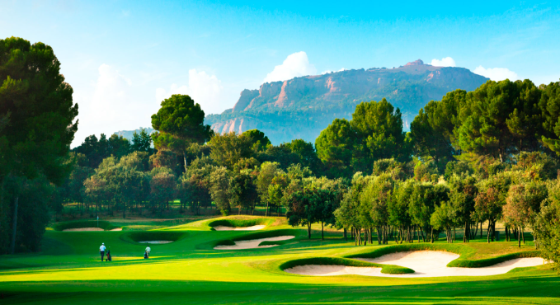
Free afternoon at leisure in Barcelona

---

DAY 2 |

---
Breakfast at your accommodation
Full day to visit Barcelona’s main attractions - Sagrada Familia, Park Guel, Camp Nou museum
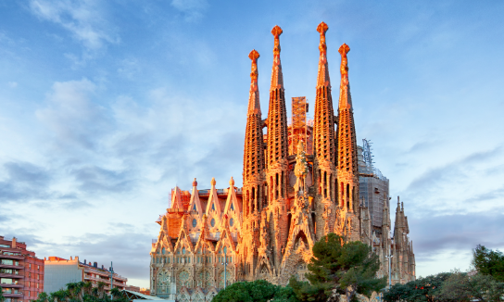
Optional: golf outing at Terramar Golf Club and visiting Sitges

---

DAY 3 |

---
Breakfast at your accommodation
Bus transfer to the golf course: Club de Golf Vallromanes
Bus transfer to the hotel in Girona
Group dinner
Night in Girona
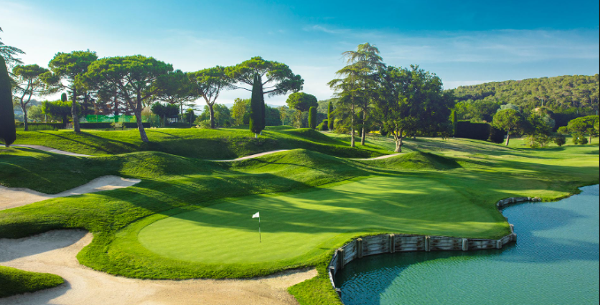

---

DAY 4 |

---
Breakfast at your accommodation
AM visits to old town of Girona
Lunch at the Old Town
Walking tour through the medieval walls and in the Rambla de la Llibertat
Bus transfer back to the hotel
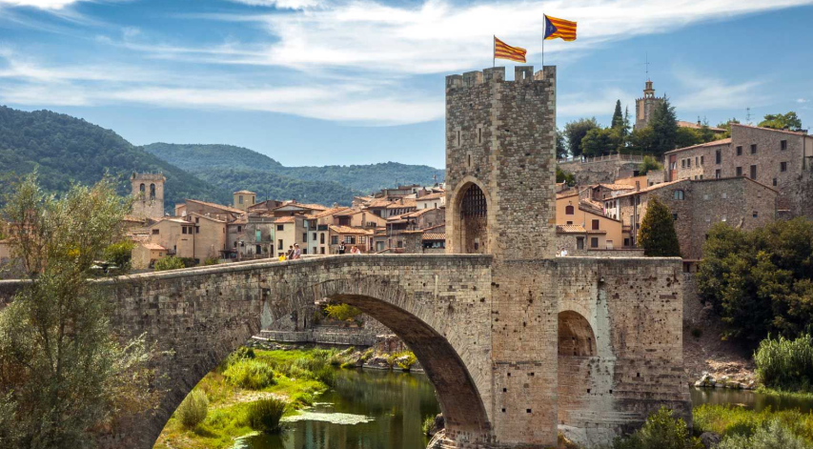
Night in Girona

---

DAY 5 |

---
Breakfast at your accommodation
Bus transfer to the golf course: Camiral golf and Resort
Optional for the afternoon:: Spa at the resort or visit the Roman baths of Caldes de Malavella
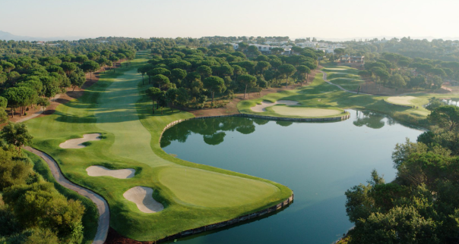
Night in Girona

---

DAY 6 |

---
Breakfast at your accommodation
Bus transfer to the golf course: Golf de Pals
Group lunch at the golf Club
Visit Pals and Begur (medieval villages)
Night in Girona
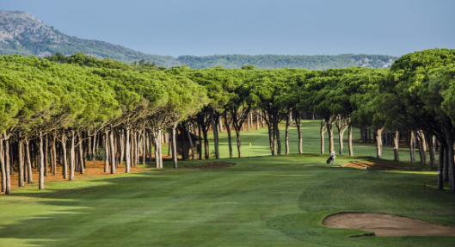

---

DAY 7 |

---
Breakfast at your accommodation
Bus transfer back to Barcelona
Optional: play golf at Emporda Golf
Optional stops: Tossa de Mar or other medieval villages
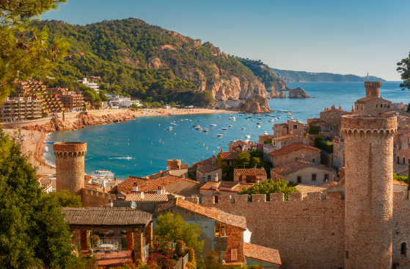
Night in Barcelona

---

DAY 8 |

---

Breakfast at your accommodation
Full free day to enjoy the city
Available activities:
- Visit to FC Barcelona
- Day trip to Sitges / beach time
Night in Barcelona

---

DAY 9 |

---
Breakfast at your accommodation
Bus or train transfer to Barcelona International airport
Flight back home

